**Insights**

1. **Role of Junction Control and Pedestrain Crossing Physical Facilities in Accident related falalities in UK**

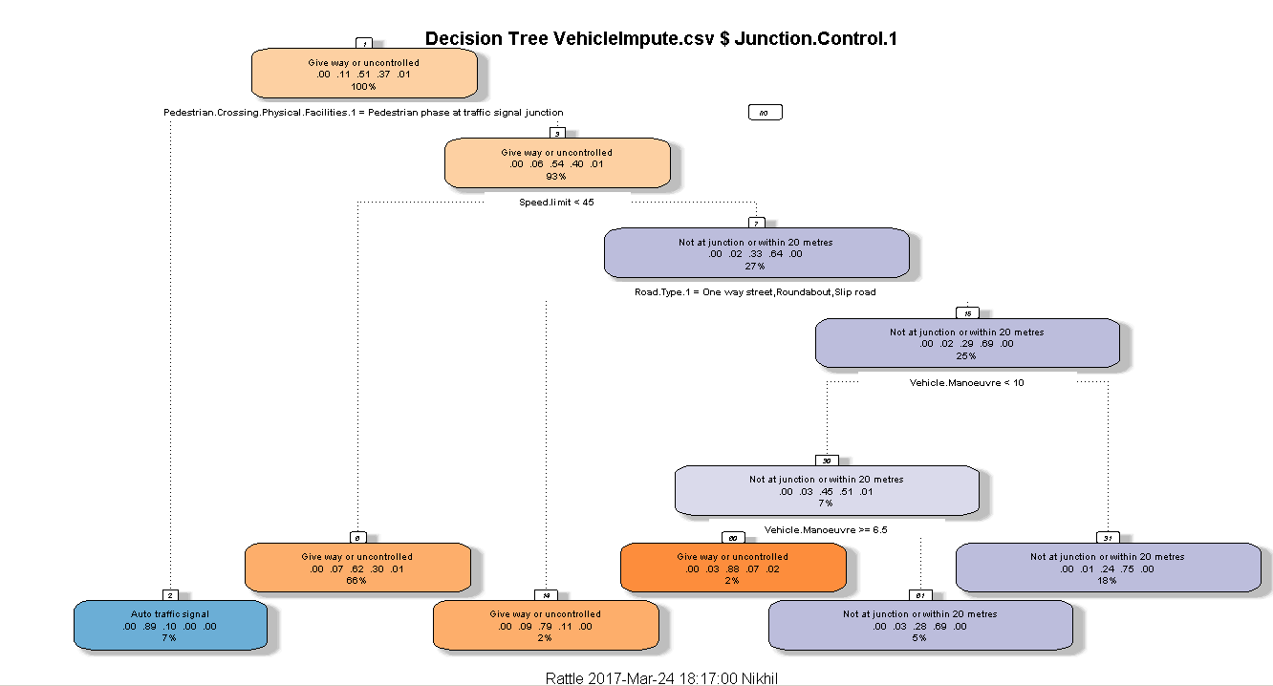

Figure 1 Decision Tree Junction Control

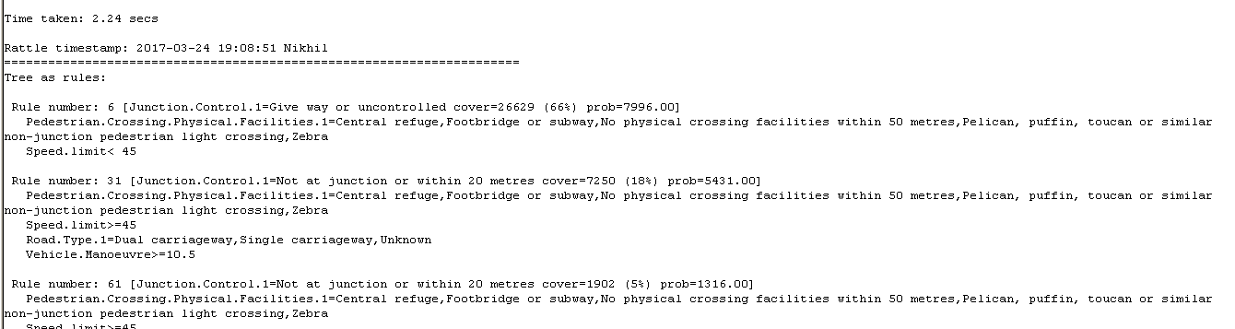

Figure 2 Decision Tree Rules

The decision tree is built with Junction Control at the node. Junction Control specifies the infrastructure and other additional factors related to the point of accident like stop sign, give way, no junction within 20 meters and how these factors which may be secondary but contribute to accidents. From the decision tree generated using rattle we can see the important parameters. We see that Pedestrian crossing human control is an important factor that results in accident. We can from rule number 6 in *Figure 2* **that 66% of accidents that take place due to no yielding or give way for vehicles in the opposite lane take place where there is No physical crossing facilities within 50 meters**, Light crossing zebra, central refugee (i.e. staggered zebra crossing without yield button mid-way). These parameters were used to develop the insight. This information can be used to deploy more crossing facilities in places where there is no crossing for more than 50 meters and lot of human crossing.

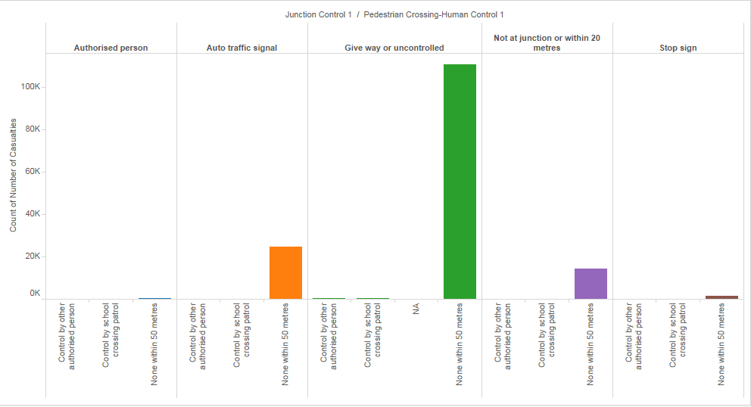

Figure 3

Insight 2 : Influence of Speed on Accidents in UK

This insight is used to identify the places where the speed cameras should be installed in UK so that the incidents can be monitored and it will help to reduce the number of incidents that occur as people who are driving will be cautious while driving in those areas due to the presence of cameras.

Most of the accidents occur in the speed limit of 30 but generally we think that the accidents occur at higher speeds. Speed limit of 30 will be generally in the city limit where the accident occurs but in the highways, there is comparatively less occurrence of accidents.

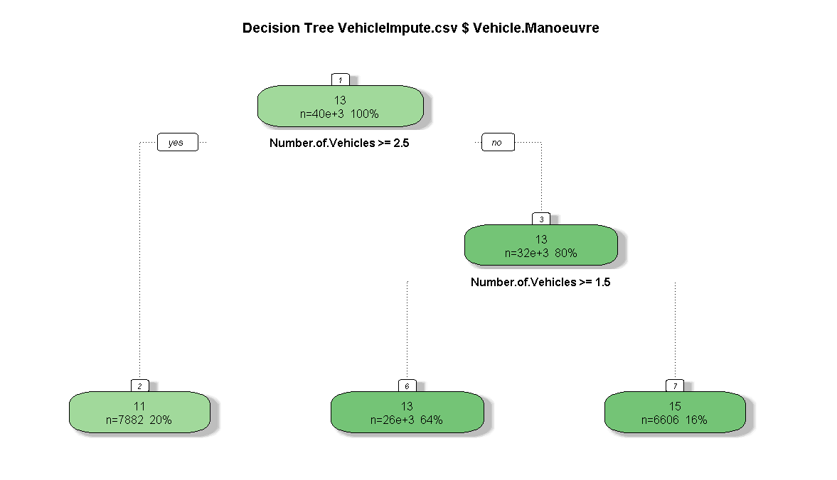

Story Sketch

The Story sketching explains two two scenarios which leads to an accident

1. Due to Central Refugee
2. No yielding

C:\Users\NAVASHREE\AppData\Local\Microsoft\Windows\INetCache\Content.Word\1.tif

It was a cloudy day in Manchester and John was on his way to the stadium for the soccer match. He had also painted his car Red due to the influence of Manchester United, his favourite team.

C:\Users\NAVASHREE\AppData\Local\Microsoft\Windows\INetCache\Content.Word\2.tif

Lesser he knows, that he will not attend the EPL Match. His excitement did not last a long time. He was driving in one of the main junctions of Manchester which had a central refugee pedestrian. Due to showers, the road was wet and dampy.

C:\Users\NAVASHREE\AppData\Local\Microsoft\Windows\INetCache\Content.Word\3.tif

There was a pedestrian who was standing in the middle junction to cross the road. The signal was green for the pedestrian, but John who was also on the way, could not stop the car at the right time due to slippery roads. The car collided with the pedestrian and it was a tragedy down the street. C:\Users\NAVASHREE\AppData\Local\Microsoft\Windows\INetCache\Content.Word\4.tif

In some other world, through the time travel, John has narrowly escaped the pedestrian accident enroute to the stadium, but another tragedy was waiting him. He must take a right at a junction, where there was another car on the opposite side.

C:\Users\NAVASHREE\AppData\Local\Microsoft\Windows\INetCache\Content.Word\5.tif

John was not patient enough and he did not give way for the opposite car though he was the second one to enter the STOP junction. So he went and collided with the other car. In both the time line, he collided due to careless mistake and costed other’s life. He eventually missed the EPL match that day.